**Exercise 1: Configuring a Basic Spring Application**

**Scenario:** Your company is developing a web application for managing a library. You need to use the Spring Framework to handle the backend operations.

**pom.xml:**

<project xmlns=<http://maven.apache.org/POM/4.0.0> xmlns:xsi="http://www.w3.org/2001/XMLSchema-instance" xsi:schemaLocation="http://maven.apache.org/POM/4.0.0 https://maven.apache.org/xsd/maven-4.0.0.xsd">

<modelVersion>4.0.0</modelVersion>

<groupId>com.library</groupId>

<artifactId>LibraryManagement</artifactId>

<version>0.0.1-SNAPSHOT</version>

<dependencies>

<dependency>

<groupId>org.springframework</groupId>

<artifactId>spring-context</artifactId>

<version>5.3.30</version>

</dependency>

<dependency>

<groupId>org.slf4j</groupId>

<artifactId>slf4j-simple</artifactId>

<version>1.7.36</version>

</dependency>

</dependencies>

</project>

**applicationContext.xml:**

<?xml version="1.0" encoding="UTF-8"?>

<beans xmlns="http://www.springframework.org/schema/beans"

xmlns:xsi="http://www.w3.org/2001/XMLSchema-instance"

xsi:schemaLocation="

http://www.springframework.org/schema/beans

http://www.springframework.org/schema/beans/spring-beans.xsd">

<bean id="bookRepository" class="com.library.repository.BookRepository"/>

<bean id="bookService" class="com.library.service.BookService">

<property name="bookRepository" ref="bookRepository"/>

</bean>

</beans>

**BookService.java:**

package com.library.service;

import com.library.repository.BookRepository;

public class BookService {

private BookRepository bookRepository;

public void setBookRepository(BookRepository bookRepository) {

this.bookRepository = bookRepository;

}

public void showBooks() {

System.***out***.println("BookService: Calling BookRepository...");

bookRepository.displayBooks();

}

}

**BookRepository.java:**

package com.library.repository;

public class BookRepository {

public void displayBooks() {

System.out.println("Displaying list of books...");

}

}

**MainApp.java:**

package com.library;

import com.library.service.BookService;

import org.springframework.context.ApplicationContext;

import org.springframework.context.support.ClassPathXmlApplicationContext;

public class MainApp {

public static void main(String[] args) {

ApplicationContext context = new ClassPathXmlApplicationContext("applicationContext.xml");

BookService bookService = (BookService) context.getBean("bookService");

bookService.showBooks();

}

}

**Project Structure:**

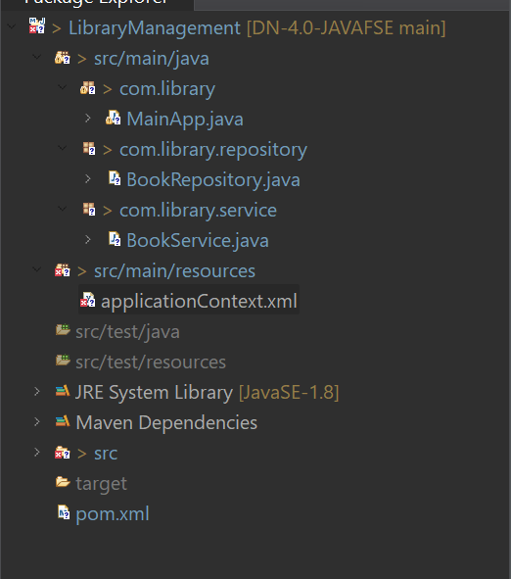

**OUTPUT:**

